**USER GUIDE**

Installation

1. Download RootTraits.zip from [*http://www*](http://www)*.*
2. Unzip the file RootTraits.zip and place it in a folder of your choice.

The following tutorial describes one example of a growing cotton root. Sample images are provided in the GUI folder.

1. Run RootTraits.m in Matlab. The main window are opened (Fig.1).

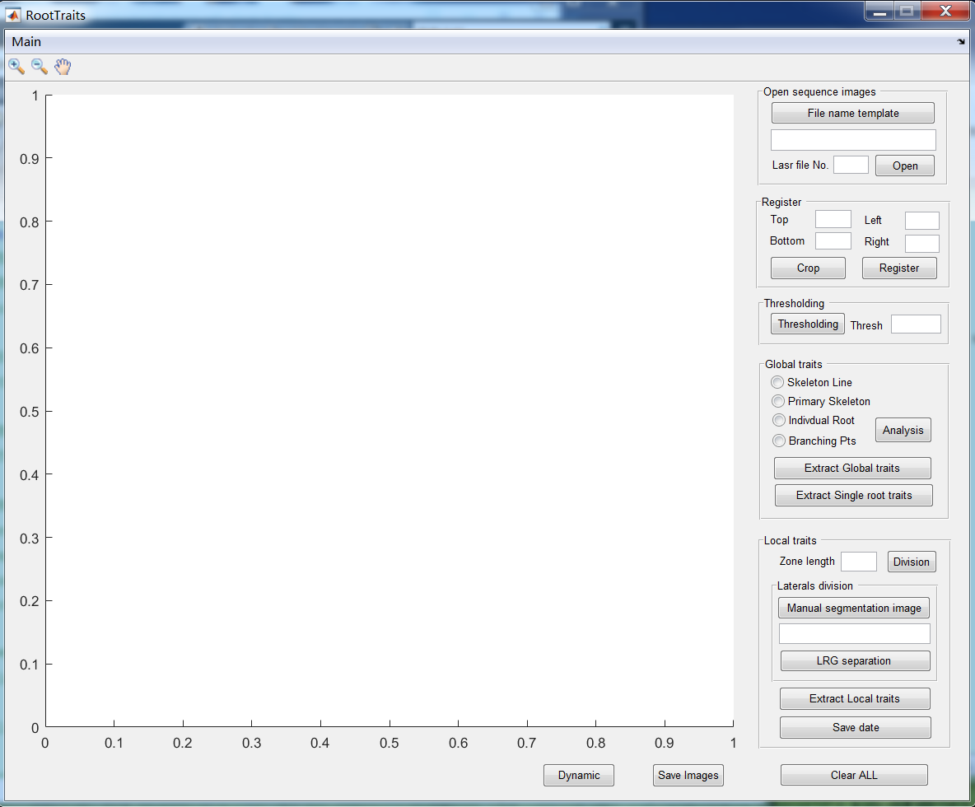

Figure 1

1. For loading multiple image files they must be numbered sequentially e.g. IMG_1 (1).jpg, IMG_1 (2).jpg etc. Click ‘File name template’ button and select an image file. The filename are appeared in the following edit text (e.g. “E:\GUI\IMG_1 (1).JPG”). Change the sequence no. in the template with # (e.g. “E:\GUI\IMG_1 (#).JPG”). Then, enter the total number of sequence images. Click ‘Open’ button. (Fig.2).

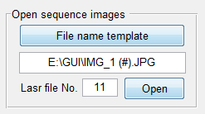

Figure 2

1. Once all images are loaded, you can view them as a movie by clicking ‘Dynamic’ button at the bottom of the main window. You can also view each frame by frame.



Figure 3

1. Enter the ‘Top’, ‘Left’, ‘Bottom’ and ‘Right’ position (e.g. 0,0,2500 and 400) and click ‘Crop’ button, the margin of the last image is removed while the root is complete, in addition, the image still with two complete white block on (Fig.4).

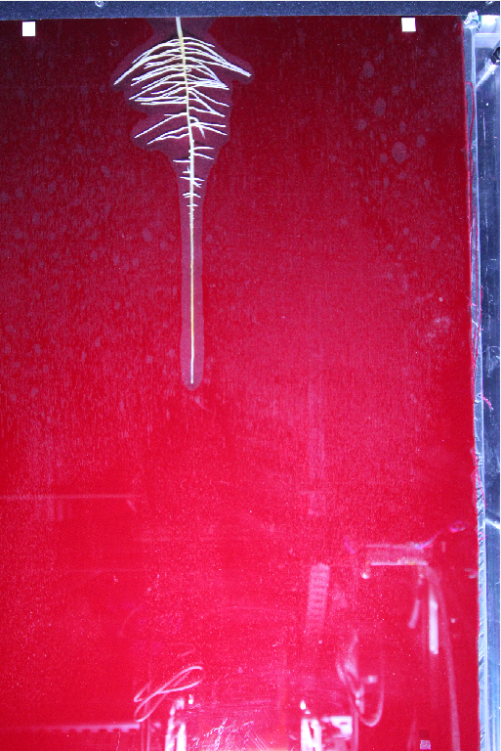 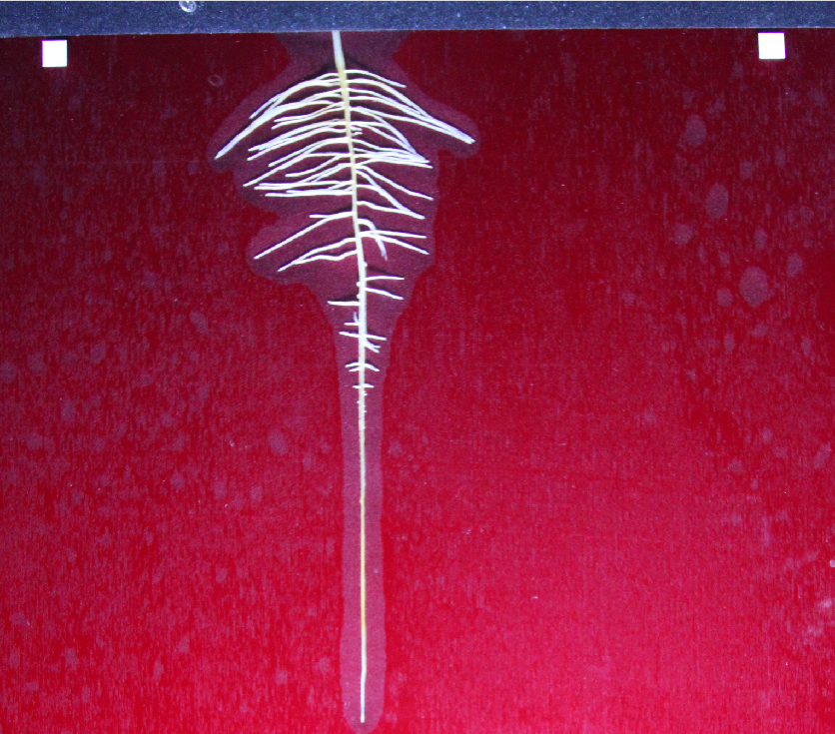

Figure 4 Before crop After crop

1. Click ‘Register’ button (Fig.5), sequence images are registered base on two white block on the top.

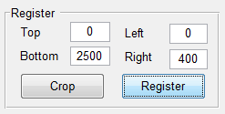

Figure 5

1. Click ‘Thresholding’ button, sequence images are thresholded to generate binary images (Fig.6). Adaptive threshold is appeared in ‘Thresh’ edit text. The thresh in the edit text can be changed, then click ‘Thresholding’ button again to achieve the binary images you satisfied. Save the sequence images by clicking ‘Save Images’ button at the bottom of the main window (Fig.3).

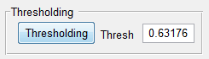

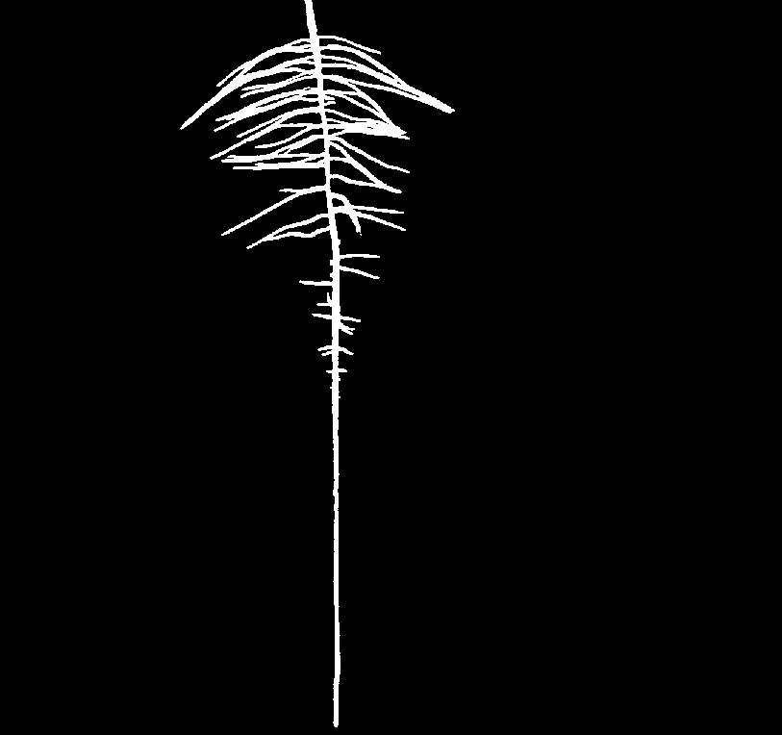

Figure 6

1. Click ‘Analysis’ button, the global root traits and individual root traits are automatic extracted (Fig.7). Click ‘Skeleton Line’, ’Primary Skeleton’, ’Individual Root’ and ‘Branching Pts’, then click ‘Dynamic’ button at the bottom of the main window (Fig.3) to view the analysis result. Click ‘Extract Global traits’ and ‘Extract Single root traits’ to save the extracted global root traits and individual root traits.

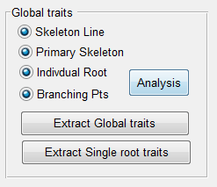 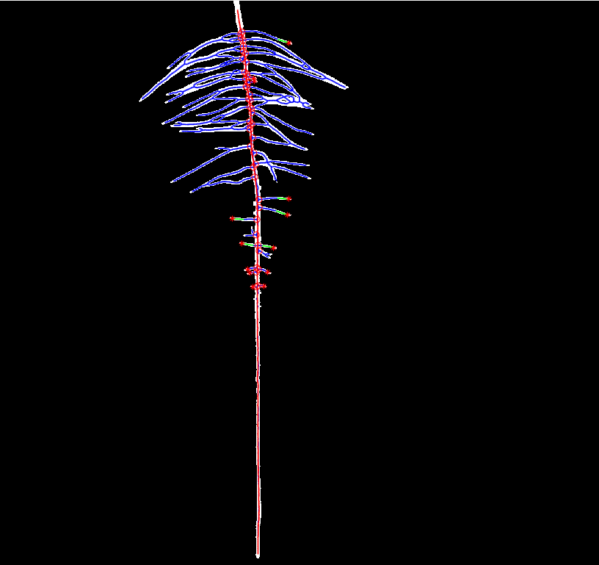

Figure 7

1. Enter the zone length in the ‘zone length’ edit text (e.g.185), and click ‘Division’ button, then the segregated zones of PR and the segregated LRGs are shown (Fig.8).



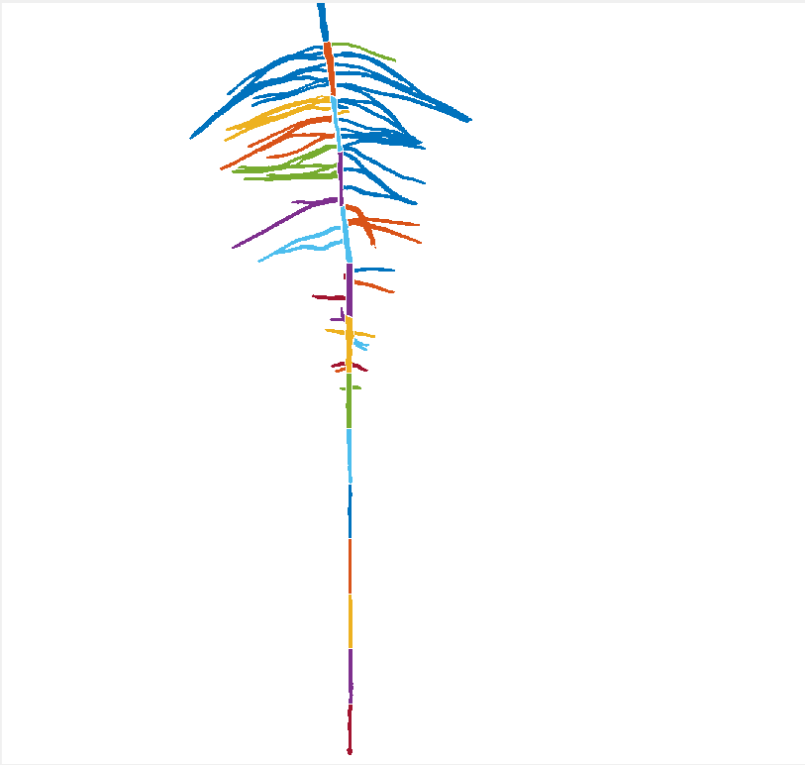

Figure 8

1. In case that one LRG belongs to more than one zones, the aggregated part of LRG has to be separate to obtain new LRGs that belongs to different zones. The manual separation has only to be done on the final sequence binary image which saved in step (6) by using PhotoShop or MeiTUXiuxiu. Click ‘Manual segmentation image’ button and select the manual separation image (e.g. E:\GUI\11bw_1.jpg), then click ‘LRG separation’ button, the aggregated part of LRG for other sequencial binary images are separated (Fig.9).

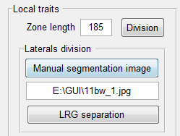

Figure 9

1. Click ‘Extract Local traits’ button, the local root traits are automatic extracted, then click ‘Save data’ to save the local LRGs information (Fig.10).

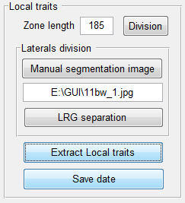 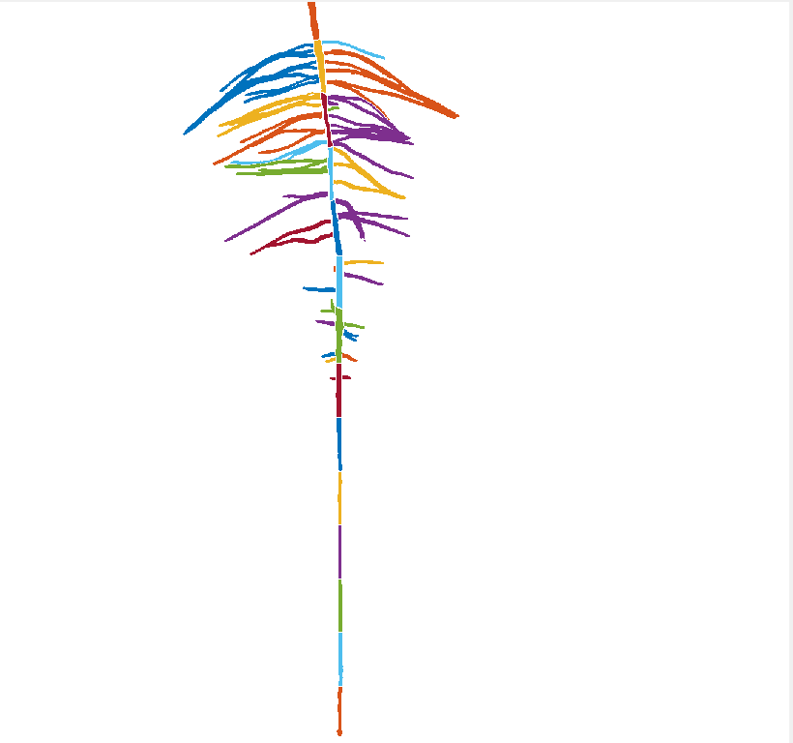

Figure 10

1. You can view the analysis result in each step by clicking ‘Dynamic’ button at the bottom of the main window.
2. After analysis, click ‘Clear All’ button at the bottom of main window to clear the memory.